Thanksgiving // Black Friday / Buy nothing day // The consumerism fever, to buy or not to buy!
Niveau concerné : 3ème Cycle 4: Rencontre avec d’autres cultures.
Thématique : La société de consommation
Activités langagières d’entraînement choisies : de la compréhension de l’oral et de l’écrit vers l’expression orale en continu.
Niveaux du CECRL visés : A2+/B1
Axe ou thèmes culturels : connaissances culturelles + connaissances linguistiques.
Problématique : Quelle place la consommation détient-elle dans notre société. Quels en sont les effets sur notre vie quotidienne ? Est-il réellement possible de vivre en dehors de la société de consommation ?
Tâche finale possible d’un l’EPI : Grâce à l’étude du comportement sociologique des populations, les élèves seront amenés à produire des posters, qui à terme, seront reliés dans un magazine publié sur le site du collège.
Objectifs de la séquence: Entraîner les élèves à construire un discours structuré et argumenté susceptible de convaincre un auditoire.
Durée : 10 environ séances
-Etape 1 : Le fête de Thanksgiving (CE)
-Etape 2 : Le Black Friday vs. Buy nothing day (CE + CO)
-Etapes 3 : « Trash Me » with Rob Greenfield (CO )
-Etape 4 : 5 Tips to Go Near kilos Zero Waste with Rob Greenfield
CO + Vidéo / Source: https://www.youtube.com/watch?v=wkETEa7ze2M&index=9&list=PLM5nCPpY9NbIJvxmZ70_VXpwcX0-3WbeK

Compétences générales
- apprendre à réfléchir sur sa consommation personnelle + sociéte de consommation.
- apprendre à défendre un point de vue.
- comprendre des documents authentiques écrits et oraux.
Compétences langagières
- écrire pour parler de la société de consommation
- parler pour débattre de la société de consommation
- lire et écouter pour argumenter un point de vue.
Compétences lexicales
- le vocabulaire de Thanksgiving
- le vocabulaire lié à la société de consommation
Compétences grammaticales
- Donner des conseils
- Donner son opinion
- Exprimer l’obligation
- Exprimer la possibilité
Evaluations
- English Test sur la fête de Thanksgiving.
- English Papers sur les lexiques.
- La création d’un POSTER sur la société de consommation.
- Présenter le poster sous forme de débat, exprimer des avis contrastés et argumenter pour convaincre.

Séance 1 & 2
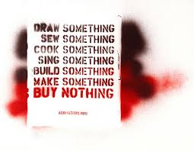
BLACK FRIDAY vs BUY NOTHING DAY.

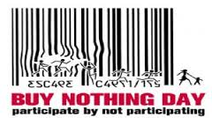

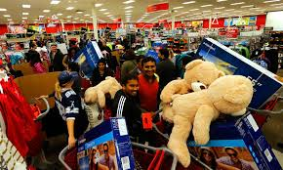

Black Friday is the day following Thanksgiving Day in the United States (the fourth Thursday of November). Since 1932, it has been regarded as the beginning of the Christmas shopping season in the U.S., and most major retailers open very early (and more recently during overnight hours) and offer promotional sales. Black Friday is not an official holiday, but California and some other states observe "The Day After Thanksgiving" as a holiday.

Buy nothing day.
https://youtu.be/1uK0_jwyh_0?list=PLB6479E8E44048E78
Buy Nothing Day (BND) is an international day of protest against consumerism. In North America, Great Britain and Sweden, Buy Nothing Day is held on the Friday after U.S. Thanksgiving, concurrent to Black Friday (on Friday)
The first « Buy Nothing Day » was organized in Canada in September 1992 "as a day for society to examine the issue of over-consumption." In 1997, it was moved to the Friday after American Thanksgiving, also called "Black Friday", which is one of the busiest shopping days in the United States.
BLACK FRIDAY vs BUY NOTHING DAY

Black Friday is the day following Thanksgiving Day in the United States (the fourth Thursday of November). Since 1932, it has been regarded as the beginning of the Christmas shopping season in the U.S., and most major retailers open very early (and more recently during overnight hours) and offer promotional sales. Black Friday is not an official holiday, but California and some other states observe "The Day After Thanksgiving" as a holiday. (Adapted from Wikipedia)

Read and pick out :
Date of the event :

An explanation of this day :

Buy Nothing Day (BND) is an international day of protest against consumerism. In North America, Great Britain and Sweden, Buy Nothing Day is held on the Friday after U.S. Thanksgiving, concurrent to Black Friday (on Friday).
The first « Buy Nothing Day » was organized in Canada in September 1992 "as a day for society to examine the issue of over-consumption." In 1997, it was moved to the Friday after American Thanksgiving, also called "Black Friday", which is one of the busiest shopping days in the United States. (Adapted from Wikipedia)
Read and pick out :
Date of the event :

An explanation of this day :

Now look at the information and find out a link between the 2 days :

Proposition de correction:
Read and pick out :
Date of the event :
It’s the Friday after Thanksgiving. It’s on the fourth (4th ) Friday of November.
An explanation of this day :
On that day, people go shopping because of big discounts.
Black Friday is the beginning of the shopping season for Christmas.
They want to buy a lot of presents for Christmas.
It’s the day for a big and busy shopping.
It’s a holiday in some states in America.
Read and pick out :
Date of the event :
It’s the Friday after Thanksgiving. It’s on the fourth (4th ) Friday of November.
An explanation of this day :
People buy nothing on that day.
It’s the contrary of the Black Friday.
People protest against consumerism.
Now look at the information and find out a link between the 2 days :
It’s the same day but there are 2 different groups of people:
*Some people buy goods, a lot of things on the Black Friday.
They love buying things!!!
*Some people buy nothing on that day.
They mustn’t buy anything. // They must buy NOTHING! / They hate buying things.
« Shoppers go crazy on Black Friday »
https://www.youtube.com/watch?v=2zBWjlkKDpA

- Note down the time:
It is a) early in the morning. b) late at night.
It is a) usual. b) exceptional.
They are a) at the cinema. b) in a stadium. c) at the supermarket.
- Circle the adjectives corresponding to the people’s attitude.
happy sorry
motivated depressed excited
crazy sad enthusiastic
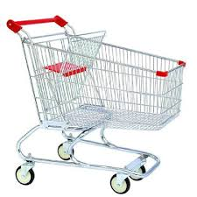
- Concentrate on what you can see in the trolleys.
- Useful goods (vegetables, food, meat, fruit…)
- presents for Christmas
- a lot of useless goods. *The trolleys are full or empty.

- Concentrate on the sellers and circle the adjectives corresponding to their attitude and feelings.
Tired busy inactive
Organized active relaxed
Lazy bored
- Concentrate on the shoppers at the end and circle the adjectives corresponding to their feelings.
Bored Enthusiastic proud
sad pleased glad Satisfied relaxed

Write down a recap of this video about the Black Friday.

The document is a video about the Black Friday. It takes place in the USA, in an American supermarket. The name of the supermarket is “Super Target”. It's 4.00 in the morning and it's very early. On this day, a lot of people go to the supermarket to buy presents for Christmas. They buy useless goods. The trolleys are full of presents. The customers run in the shops and they scream. They are crazy and very excited because there are big discounts.They spend a lot of money for toys.
After the “war”, people are ready for Christmas.

BUY NOTHING DAY
source Youtube: https://www.youtube.com/watch?v=toEdPhBdfaU

      - The country : ……………………………….
The animal : …………………………………………
Explain:………………………………………………………………………………………………………………………………
………………………………………………………………………………………………………………………………………………

      - Circle the corresponding words to the issue.

pollution over-consumption
environnent problems poverty unemployment
too much trash (GB) / too much rubbish (USA) drought
deforestation

3. The message conveyed by Buy Nothing Day celebration is:
a). over-consumption leads to the destruction of our environment.
b). there are no solutions to the problem of over- consumption.
c). over-consumption is the solution to environment problems
4. What are the advice you can give to the Americans and the entire world ?
………………………………………………………………………………………………………………………………………………
………………………………………………………………………………………………………………………………………………

BUY NOTHING DAY
source Youtube: https://www.youtube.com/watch?v=toEdPhBdfaU
1- The country : The USA The animal : the pig
Explain: The pig is big. A pig can eat anything. It means that Americans people consume too much and they buy too much.
2- Circle the corresponding words to the issue.
pollution over-consumption
environnent problems poverty unemployment
too much trash (GB) / too much rubbish (USA) drought
deforestation
3- The message conveyed by Buy Nothing Day celebration is:
a). over-consumption leads to the destruction of our environment.
b). there are no solutions to the problem of over- consumption.
c). over-consumption is the solution to environment problems
4- What are the advice you can give to the Americans and the entire world ?
They shouldn’t consume so much.
They shouldn’t buy so much = they should buy less
They should heal the world
They should make a change in their consumption.
They should make a better place for the living.
“No shopping, save the planet, buy nothing”. We must protect the planet and we mustn't kill it.
They must reduce their trash and their consumption to protect the planet .
The planet can die if we don't care about it.
PRL : GIVING ADVICE (Exprimer le conseil)
SHOULD + BV
SHOULDN’T+ BV
NB : Advice ( n pl) = les conseils / A piece of advice = un conseil
Advise (v )= conseiller ==> give advice
+++ Giving Opinion + linking words

WRITING
Use the information about the videos you watched, choose one day and explain it.
Then, give your opinion about the attitude of the Americans on that day.
EE 2: Black Friday vs Buy nothing day
Tu vas devoir choisir un des 2 jours, l’expliquer en utilisant les informations dans ton cahier et donner ton avis.
Qualité de l’écrit | 2 3 4 5 6 points
L’élève a donné son opinion | 0 1 2 3 points
Correction grammaticale | 1 2 3 points
Vocabulaire (varié et riche) | 1 2 3 points
Connecteurs logiques | 0 1 2 3 points
Orthographe, majuscules | 1 2 points
Présentation, ponctuation | 1 2 points
Connaissances culturelles | 1 2 3 points
Nombre de mots (mini150 max 200) | 0 1 2 points
Total | / 27 points

Keep Calm & write on !!! Miss D
EE 2: Black Friday vs Buy nothing day

Tu vas devoir choisir un des 2 jours, l’expliquer en utilisant les informations dans ton cahier et donner ton avis.
Qualité de l’écrit | 2 3 4 5 6 points
L’élève a donné son opinion | 0 1 2 3 points
Correction grammaticale | 1 2 3 points
Vocabulaire (varié et riche) | 1 2 3 points
Connecteurs logiques | 0 1 2 3 points
Orthographe, majuscules | 1 2 points
Présentation, ponctuation | 1 2 points
Connaissances culturelles | 1 2 3 points
Nombre de mots | 0 1 2 points
Total | / 27 points

Keep Calm & write on !!! Miss D

Proposition de correction
In the USA, The Black Friday is on the fourth Friday of November, the day after Thanksgiving. It’s the beginning of the Christmas shopping season. Actually, the shops open very early in the morning. People are excited because there are big discounts on that day, consequently, they want to buy a lot of presents for Christmas, that’s why they get up very early in the morning. They run and scream, pushing their trolley. The trolleys are full of presents for Christmas. The shoppers are so proud of their purchase but usually they buy a lot of useless goods !
American people go crazy on the “Black Friday” in the USA. After the “war”, they are ready to celebrate Christmas.

In the USA, The “Buy Nothing Day” is on the fourth Friday of November, the day after Thanksgiving. On that day, a group of people buys nothing because they protest against consumerism. It’s the same day as the “Black Friday”. They want to show the planet is going to die if we don’t protect the planet by reducing our rubbish. However it's difficult to change the mentalities of crazy people who love discounts. “No shopping, save the planet, buy nothing”. According to me, we must protect the planet and we mustn't kill it. The planet can die if we don't care about it.
Trash Me with Rob Greenfield
(Source : youtube.com)
https://www.youtube.com/watch?v=KH20tkp_EhY&list=PLM5nCPpY9NbIJvxmZ70_VXpwcX0-3WbeK&index=8
- Try and identify the rules of the experiment:
-……………………………………………………………………………………………………………………………………………
-………………………………………………………………………………………………………………………………………………
-………………………………………………………………………………………………………………………………………………
-………………………………………………………………………………………………………………………………………………
-………………………………………………………………………………………………………………………………………………
- Try and identify the place and the duration of this experiment:
- ………………………………………………………………………………………………………………………………………………
- ………………………………………………………………………………………………………………………………………………
3- Try and identify the reasons of this experiment:
- …………………………………………………………………………………………………………………………………
-………………………………………………………………………………………………………………………………………………
-………………………………………………………………………………………………………………………………………………
-………………………………………………………………………………………………………………………………………………
-………………………………………………………………………………………………………………………………………………
Trash Me with Rob Greenfield
(Source : youtube.com)
https://www.youtube.com/watch?v=KH20tkp_EhY&list=PLM5nCPpY9NbIJvxmZ70_VXpwcX0-3WbeK&index=8
1- Try and identify the rules of the experiment :
1 - He must consume, eat and shop like any other person does.
2 - He must wear the trash he creates.
3 - He must walk in the street so people can see him.
4 - He must accept everything.
5 - He mustn't throw his trash away.

2- Try and identify the place and the duration of this experiment:
- He is in NYC ==> in the USA // in Times Square ==> in Manhattan
- The experiment lasts 30 days = 1 month

3- Try and identify the reasons of this experiment :
1- To show us all the trash we throw away in a month. = He wants to know or to show what it looks like to wear any piece of trash he creates in a month.
2- To show that American people consume too much.
3- To protest against consumerism.
4- To pay tribute to the associations that protect the planet. = The planet can die because of pollution.
5- “Out of site out of mind” ==> American people create too much trash!
6- To give a lesson about pollution.

5 Tips to Go Near Zero Waste with Rob Greenfield
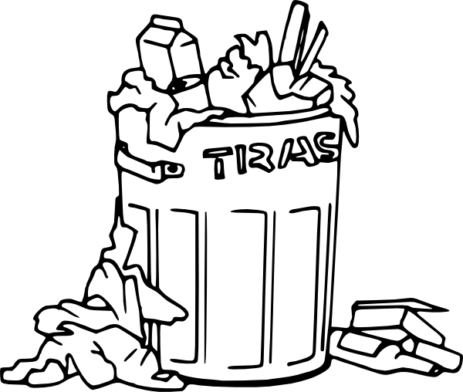
WORDBOX # 5 :
1 pound = 0,45 Kg 2- trash (n) = rubbish(n)
3- A garbage can: 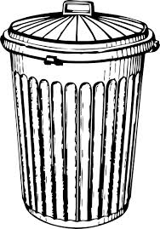
Instead of = au lieu de
Should + BV ➔ expression du conseil
4-- Ditch (v) = Throw out(v) 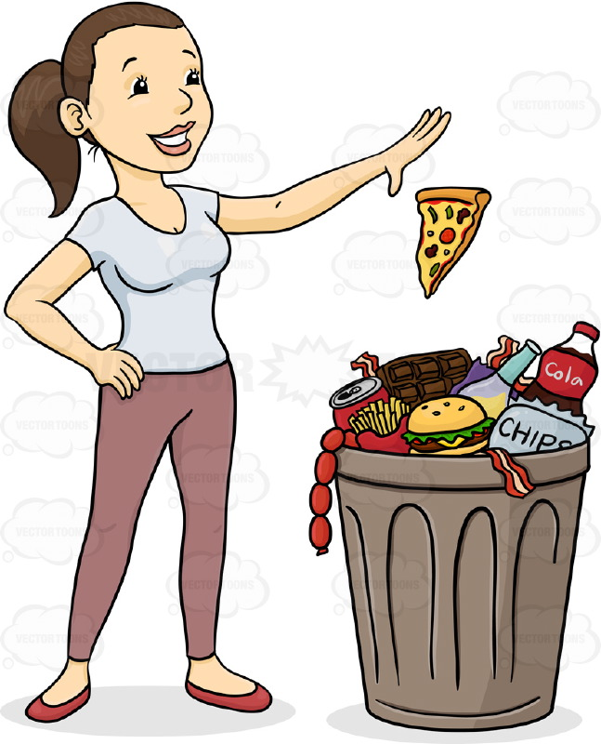
5-Use (v) : 6- reuse (v) :
7- usable (adj) : 8- reusable (adj) : 9- unreusable (adj):
10- a cup: 11- a mug: 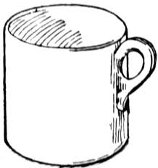
12- dishes: 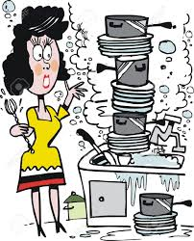 13- utensils:

14- a fork : 15- a spoon: 16- a knife:
15- to-go containers
16-A towel: 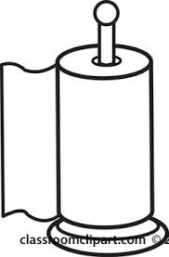 17- a napkin: 18- a tissue : 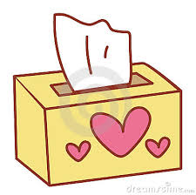

5 Tips to Go Near Zero Waste with Rob Greenfield
CO + Vidéo / Source: https://www.youtube.com/watch?v=wkETEa7ze2M&index=9&list=PLM5nCPpY9NbIJvxmZ70_VXpwcX0-3WbeK
Watch and highlight the numbers you hear:
19th 48 90 13
58 3 33% 23
4,5 38% 5,4 100%

2-Use the correct number with the corresponding explanation:
………… day of the experiment
………… pounds of trash in 19 days = ……………………………….. kilograms
………… pounds of trash per day // ……… pounds of trash per day for the average American.
= ……………………. kilogrammes
………… less trash than the average American.

Conclusion: ……………………………………………………………………………………………………………………………

3-Watch again and identify 2 nicknames for Rob Greenfield:
1-………………………………………… 2- …………………………………………..
4-Watch again : circle with a color the wrong objects and with another color the right objects to protect the planet.
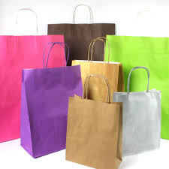

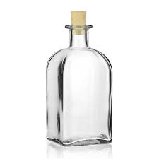

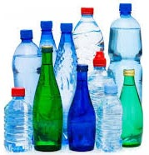
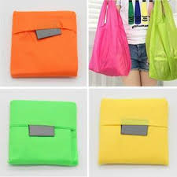
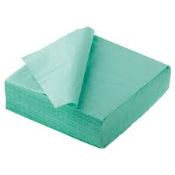

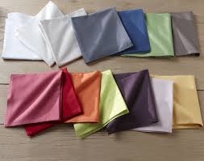
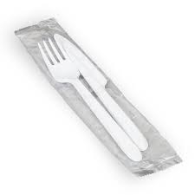

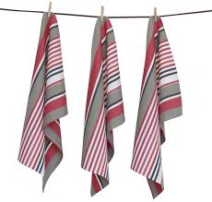

5-Give 3 reasons why you must do that :

CORRECTION
- Use the correct number with the corresponding explanation:
19 th day of the experiment
58 pounds of trash in 19 days ( 29 kilos)
3 pounds ( = 1,5 kilos) of trash per day // 4,5 pounds ( 2,25 kilos) of trash per day for the average American.
33 % less trash than the average American.
- Watch again and identify 2 nicknames for Rob Greenfield:
- Trash Man 2- Trash monster

5-Give 3 reasons why you must do that:
- You reuse the things you have. You consume less. You reduce your consumption.
- You save money.
- You protect the planet = You heal the world
RECAP
Problems | Solutions
Ditch plastic and paper bags. | You should get a reusable bag
Don’t use paper towels, napkins and tissues. | You should usable cloths ➔ you can wash it!
Don’t use disposal cups. | You should bring your own cup or your mug.
Don’t use plastic or papers dishes, plastic forks and spoons or to-go containers. | You should carry your own dishes, your own utensils…
Ditch the bottled water. | You should use a reusable bottle.

EXPRESSION ECRITE
Je peux écrire un texte sur la surconsommation et les solutions possibles.
• L'utilisation du lexique de la surconsommation, de ses conséquences et des alternatives.
• L’utilisation de l’expression du conseil, de la possibilité, de l’obligation et de l’interdiction.
Can you explain what overcomsumption is ?
What can we do ? What must we do ? Whant should we do ?
Can you explain the problem due to consumerism ?
150 to 180 wordsale en
Qualité de l’écrit | 2 3 4 5 6 points
L’élève a donné des solutions | 0 1 2 3 points
Correction grammaticale | 1 2 3 points
Vocabulaire (varié et riche) | 1 2 3 points
Connecteurs logiques | 0 1 2 3 points
Orthographe, majuscules | 1 2 points
Présentation, ponctuation | 1 2 points
Connaissances culturelles | 1 2 3 points
Nombre de mots (mini150 max 180) | 0 1 2 points
Total | / 27 points
Keep calm and go green…
Miss D.

EXPRESSION ECRITE
Je peux écrire un texte sur la surconsommation et les solutions possibles.
Proposition de correction :
The planet is in danger because of overconsumption. People, and particularly the Americans, consume too much. The average American consume 4,5 pounds (2,25 kg) of trash per day. Indeed, overconsumption is bad for the planet because it creates pollution and it leads to the destruction of our environment. We buy a lot of useless goods, even more on the “Black Friday”, that is a day with big discounts in the USA and everywhere in the world. People go crazy on that day and they buy useless goods even if they don’t need them. On the contrary, we should help the planet and join the “Buy nothing day” movement. The movement protests against consumerism.
Thus, we like Rob Greenfield when he tries to give us solutions to reduce our consumption in our everyday life. According to him, we should use reusable utensils instead of plastic ones, or, we should use our own dishes instead of to-go-containers, and we should use cloth towels instead of napkins. In fact, we should use reusable stuff instead of unreusable ones. I think that these tips are very good ones.
Consequently, we create too much trash and the planet is in danger. We must reduce our consumption, reuse and recycle. We must go green. We must reduce our consumption. We must use our power to heal the world. Let’s try!

2 Proposition de correction : mots de liaison
The planet is in danger because of overconsumption. People, and particularly the Americans, consume too much. The average American consume 4,5 pounds (2,25 kg) of trash per day. Indeed, overconsumption is bad for the planet because it creates pollution and it leads to the destruction of our environment. We buy a lot of useless goods, even more on the “Black Friday”, that is a day with big discounts in the USA and everywhere in the world. People go crazy on that day and they buy useless goods even if they don’t need them. On the contrary, we should help the planet and join the “Buy nothing day” movement. The movement protests against consumerism.
Thus, we like Rob Greenfield when he tries to give us solutions to reduce our consumption in our everyday life. According to him, we should use reusable utensils instead of plastic ones, or, we should use our own dishes instead of to-go-containers, and we should use cloth towels instead of napkins. In fact, we should use reusable stuff instead of unreusable ones. I think that these tips are very good ones.
Consequently, we create too much trash and the planet is in danger. We must reduce our consumption, reuse and recycle. We must go green. We must reduce our consumption. We must use our power to heal the world. Let’s try!

3 Proposition de correction : fait de langue
The planet is in danger because of overconsumption. People, and particularly the Americans, consume too much. The average American consume 4,5 pounds (2,25 kg) of trash per day. Indeed, overconsumption is bad for the planet because it creates pollution and it leads to the destruction of our environment. We buy a lot of useless goods, even more on the “Black Friday”, that is a day with big discounts in the USA and everywhere in the world. People go crazy on that day and they buy useless goods even if they don’t need them. On the contrary, we should help the planet and join the “Buy nothing day” movement. The movement protests against consumerism.
Thus, we like Rob Greenfield when he tries to give us solutions to reduce our consumption in our everyday life. According to him, we should use reusable utensils instead of plastic ones, or, we should use our own dishes instead of to-go-containers, and we should use cloth towels instead of napkins. In fact, we should use reusable stuff instead of unreusable ones. I think that these tips are very good ones.
Consequently, we create too much trash and the planet is in danger. We must reduce our consumption, reuse and recycle. We must go green. We must reduce our consumption. We must use our power to heal the world. Let’s try!

4- Proposition de correction : Lexique
The planet is in danger because of overconsumption. People, and particularly the Americans, consume too much. The average American consume 4,5 pounds (2,25 kg) of trash per day. Indeed, overconsumption is bad for the planet because it creates pollution and it leads to the destruction of our environment. We buy a lot of useless goods, even more on the “Black Friday”, that is a day with big discounts in the USA and everywhere in the world. People go crazy on that day and they buy useless goods even if they don’t need them. On the contrary, we should help the planet and join the “Buy nothing day” movement. The movement protests against consumerism.
Thus, we like Rob Greenfield when he tries to give us solutions to reduce our consumption in our everyday life. According to him, we should use reusable utensils instead of plastic ones, or, we should use our own dishes instead of to-go-containers, and we should use cloth towels instead of napkins. In fact, we should use reusable stuff instead of unreusable ones. I think that these tips are very good ones.
Consequently, we create too much trash and the planet is in danger. We must reduce our consumption, reuse and recycle. We must go green. We must reduce our consumption. We must use our power to heal the world. Let’s try!

5- Proposition de correction : connaissances culturelles
The planet is in danger because of overconsumption. People, and particularly the Americans, consume too much. The average American consume 4,5 pounds (2,25 kg) of trash per day. Indeed, overconsumption is bad for the planet because it creates pollution and it leads to the destruction of our environment. We buy a lot of useless goods, even more on the “Black Friday”, that is a day with big discounts in the USA and everywhere in the world. People go crazy on that day and they buy useless goods even if they don’t need them. On the contrary, we should help the planet and join the “Buy nothing day” movement. The movement protests against consumerism.
Thus, we like Rob Greenfield when he tries to give us solutions to reduce our consumption in our everyday life. According to him, we should use reusable utensils instead of plastic ones, or, we should use our own dishes instead of to-go-containers, and we should use cloth towels instead of napkins. In fact, we should use reusable stuff instead of unreusable ones. I think that these tips are very good ones.
Consequently, we create too much trash and the planet is in danger. We must reduce our consumption, reuse and recycle. We must go green. We must reduce our consumption. We must use our power to heal the world. Let’s try!
EXPRESSION ECRITE
Je peux écrire un texte sur la surconsommation et les solutions possibles.
6 Proposition de correction : « ones »
The planet is in danger because of overconsumption. People, and particularly the Americans, consume too much. The average American consume 4,5 pounds (2,25 kg) of trash per day. Indeed, overconsumption is bad for the planet et because it creates pollution and it leads to the destruction of our environment. We buy a lot of useless goods, even more on the “Black Friday”, that is a day with big discounts in the USA and everywhere in the world. People go crazy on that day and they buy useless goods even if they don’t need them. On the contrary, we should help the planet and join the “Buy nothing day” movement. The movement protests against consumerism.
Thus, we like Rob Greenfield when he tries to give us solutions to reduce our consumption in our everyday life. According to him, we should use reusable utensils instead of plastic ones, or, we should use our own dishes instead of to-go-containers, and we should use cloth towels instead of napkins. In fact, we should use reusable stuff instead of unreusable ones. I think that these tips are very good ones.
Consequently, we create too much trash and the planet is in danger. We must reduce our consumption, reuse and recycle. We must go green. We must reduce our consumption. We must use our power to heal the world. Let’s try!

CO : EVALUATION Source : Bloggers ript audio
CD: 84 ( audio dans les vidéos sur la clé)
Humans have been on Earth for only a fraction of its lifetime. Yet, in that fraction we have caused mass extinction, mass polluting, mass harm to our planet. And for what? For this...
The wise Abenaki man once said that when the rivers are all dried up, and the trees are all cut down, man will then realize he cannot eat money.
Nature is beautiful. It gives us clean air, clean water, good food and everything we need to survive. But we deem our- selves rulers of nature.
And we have abused nature in everything that it does for us. We deny that our consumption, our lust for more is causing the pollution and waste that is destroying our beautiful plan- et. When in fact we are the cause of this problem. It’s not the large corporations, governments and politicians causing this destruction. It is us, it is our demand for resources that will soon run out.
Yes, we are the source of this problem but that means we have the power to be the solution as well. We can fix this. We have the ability to ditch the system that doesn’t work and create a new one.
Author Anthony Weston states that “dreams are after all what drive us”.
The natural question is: what other grand things might we dream now?
Well we dream of creating a world where people live together, work together, solve problems together, share resources together because by working together, we naturally save ressources, money while at the same time increase community, resilience and strength of our system.
So we set out to create a website that organizes community sharing. This website is a platform to connect people who are willing to lend dormant tools to people who need them. We want this site to grow or community and save resources. By lending and borrowing tools you meet and make connections with people you would not have otherwise met.
They say sharing is caring. Sharing is caring for our family, for our community, for our environment. That is why we dream of creating a world that shares. Gandhi said it right: “There’s enough in this world for every man’s need but not for every man’s greed”.

They say sharing is caring. Sharing is caring for our family, for our community, for our environment. That is why we dream of creating a world that shares. Gandhi said it right: “There’s enough in this world for every man’s need but not for every man’s greed”.

TACHE FINALE:
Les élèves doivent réaliser en groupe un débat, exprimer des avis contrastés et argumenter pour convaincre.
Together define what action you are working on (ocean cleaning, recycling, zero waste lifestyle...) and prepare the interview.

TACHE FINALE de l’EPI :
Les élèves devront produire des affiches comportant un message fort dans le but de créer un magazine en ligne avec l’utilisation de l’outil « mad magz » sur la place de la consommation dans notre société et les effets sur la vie quotidienne.

CREATE A DEBATE ABOUT CONSUMERISM AND DEFEND YOUR IDEAS.
PPI : Je peux discuter de problèmes environnementaux liés à la surconsommation.
Group # …….. : Niveau : A2➔ B1
Names: …………………………………………………………………………………………………………………………………………………………
Tu devras réaliser un débat sur la surconsommation, exprimer des avis contrastés et argumenter pour convaincre. Vous vous enregistrerez sur mon dictaphone au collège.
Durée : 1’30 à 2’00 Groupe : 4 personnes maximum.
Prise de parole en continu et en interaction | Note (miss D.)
Ennoncés très courts, stéréotypés et isolés / 2  Dialogue bref et simple (liste de points successifs) / 4  Dialogue organisé (présentation plus personnelle) / 6 | / 6
Proposer un dialogue sous forme de débat | / 1
Établir un constat sociétal | / 1
Donner au moins 2 conseils | / 2
Donner au moins une obligation | / 1
Varier les tournures pour donner votre opinion | / 2
Présentation orale convaincante du groupe | / 3
Prononciation et intonation | / 2
Respect du temps 1’30 à 2’00 | / 1
Total | / 19

KEEP CALM & DEBATE!
Miss D.

CREATE AN INTERVIEW ABOUT CONSUMERISM AND DEFEND YOUR IDEAS.
PPI : Je peux discuter de problèmes environnementaux liés à la surconsommation.
Group # …….. : Niveau : A2➔ B1
Names: …………………………………………………………………………………………………………………………………………………………
Student A: you are a green activist working for an ecological organization
Student B: you areTV journalist about an ecological action you are leading.
Together define what action the activist is working on (ocean cleaning, recycling, zero waste lifestyle...) and prepare the interview.
Vous vous enregistrerez sur mon dictaphone au collège.
Durée : 1’30 à 2’00 Groupe : 4 personnes maximum.
Prise de parole en continu et en interaction | Note
Ennoncés très courts, stéréotypés et isolés /2  Dialogue bref et simple (liste de points successifs) /4  Dialogue organisé (présentation plus personnelle) /6 | / 6
Proposer un dialogue sous forme d’interview | / 1
Établir un constat sociétal | / 1
Donner au moins 2 conseils | / 2
Donner au moins une obligation | / 1
Varier les tournures pour donner votre opinion | / 2
Présentation orale convaincante du groupe | / 3
Prononciation et intonation | / 2
Respect du temps 1’30 à 2’00 | / 1
Total | / 19
KEEP CALM & GO GREEN!
Miss D.

