1ère STL
Counter-intelligence during WW2 - Session 1
The Enigma machine

What is the Enigma machine ?

- Alan Turing’s biography

Video related (0 to 1min30s) : https://www.youtube.com/watch?v=gtRLmL70TH0
First step : write down in the first box what you can hear and understand during the two first viewings.

Second step : after the third viewing, try to pick up some information about Alan Turing’s personal life and his work.

Personal life : ……………………………………………………………………………………………………………………………………………………………….

…………………………………………………………………………………………………………………………………………………………………………………….

…………………………………………………………………………………………………………………………………………………………………………………….

…………………………………………………………………………………………………………………………………………………………………………………….

Alan Turing’s work : ……………………………………………………………………………………………………………………………………………………..

…………………………………………………………………………………………………………………………………………………………………………………….

…………………………………………………………………………………………………………………………………………………………………………………….

…………………………………………………………………………………………………………………………………………………………………………………….

…………………………………………………………………………………………………………………………………………………………………………………….

- The movie : Imitation game
Extract n°1 : 8min30s 14 min30s
1/ At the beginning, does Alan Turing make a good impression to the commander Denniston ?

………………………………………………………………………………………………………………………………………………………………………………………………..

………………………………………………………………………………………………………………………………………………………………………………………………..

2/ Does Alan Turing agree to work in a team ?

………………………………………………………………………………………………………………………………………………………………………………………………..

………………………………………………………………………………………………………………………………………………………………………………………………..

Extract n°2 : 1h12min30s 1h19min
3/ What happens in this extract ?

………………………………………………………………………………………………………………………………………………………………………………………………..

………………………………………………………………………………………………………………………………………………………………………………………………..

………………………………………………………………………………………………………………………………………………………………………………………………..

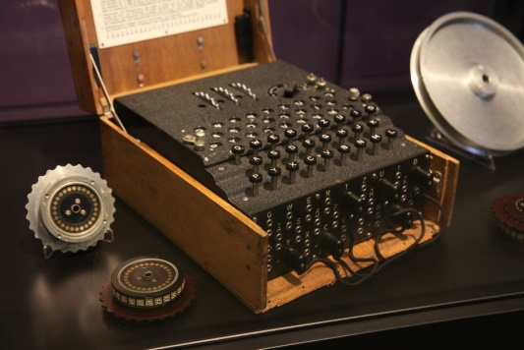
- The enigma machine

Description of the machine
1/ How many keyboard does the machine have ?

……………………………………………………………………………………………………………………………

……………………………………………………………………………………………………………………………

2/ Do the rotors all turn at the same frequency ?

………………………………………………………………………………………………………………………………………………………………………………………………..

………………………………………………………………………………………………………………………………………………………………………………………………..

3/ Try out to use the machine thanks to the simulation (link below). Then explain how the machine works.

………………………………………………………………………………………………………………………………………………………………………………………………..

………………………………………………………………………………………………………………………………………………………………………………………………..

………………………………………………………………………………………………………………………………………………………………………………………………..

………………………………………………………………………………………………………………………………………………………………………………………………..

………………………………………………………………………………………………………………………………………………………………………………………………..

………………………………………………………………………………………………………………………………………………………………………………………………..

Let’s have a look to the Enigma simulation : http://enigmaco.de/enigma/enigma.html

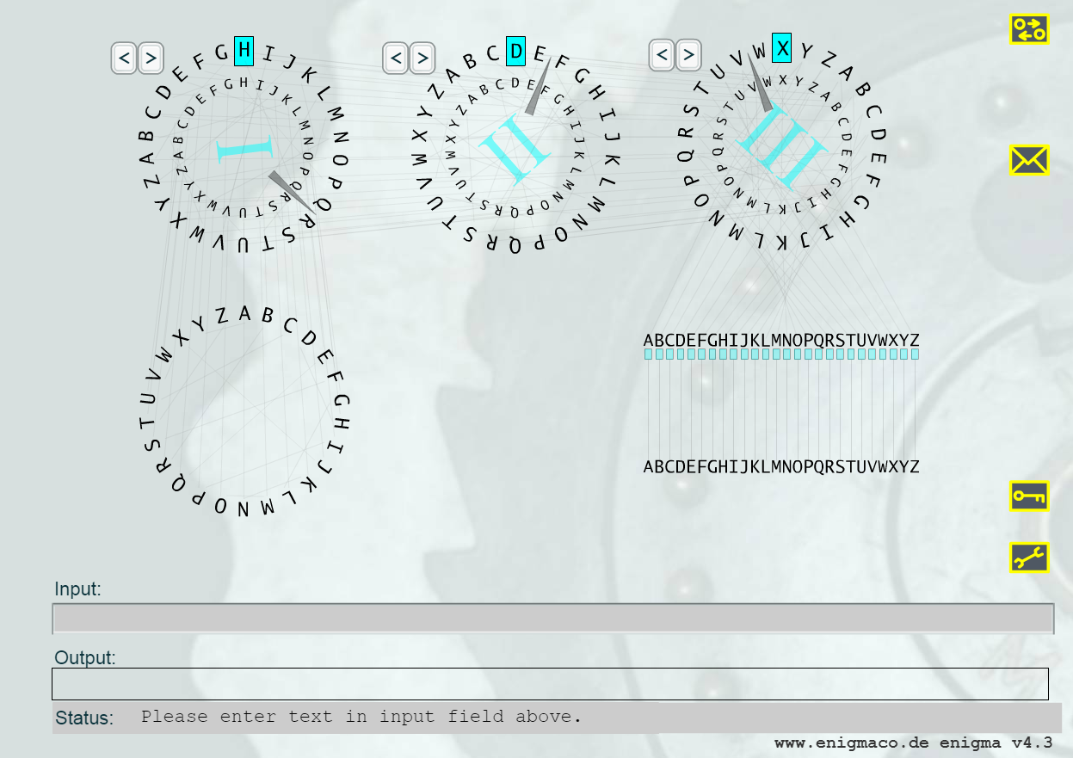

1ère STL
Counter-intelligence during WW2 - Session 2
Invisible ink and process of revelation

- Invisible ink with milk (or lemon juice)
Lab equipment : a piece of paper, milk (or lemon juice), a toothpick, a heater (heating device).

Write the invisible message :
- Write a message to your neighbour with milk (or lemon juice) and a toothpick on a piece of paper,
Be careful, don’t imbibe the paper too much, your message has to be as invisible as possible.
- Once the paper is dry (you can help by blowing on the paper) give your message to your neighbour.

Reveal the message :
- Hold the piece of paper above the heating device for a few seconds : the secret message appears !

- Invisible ink with potassium ferrocyanide
Lab equipment : a piece of paper, a solution of potassium ferrocyanide, a toothpick, a solution of iron chloride and a paintbrush.

Write the invisible message :
- Write a message to your neighbour with a solution of potassium ferrocyanide with a toothpick,
Be careful, don’t imbibe the paper too much, your message has to be as invisible as possible.
- Once the paper is dry (you can help by blowing on the paper) give your message to your neighbour.

Reveal the message :
- Wash the paintbrush with distilled water in a little beaker,
- Spread some solution of iron chloride on the paper with the paintbrush to make the message appear.

- Invisible ink with copper sulfate
Lab equipment : a piece of paper, a solution of copper sulfate, a toothpick, a crystallizer filled with a solution of ammonia (30%) into the extractor hood.

Write the invisible message :
- Write a message to your neighbour with a solution of copper sulfate with a toothpick,
Be careful, don’t imbibe the paper too much, your message has to be as invisible as possible.
- Once the paper is dry (you can help by blowing on the paper) give your message to your neighbour.

Reveal the message :
- Put the piece of paper on the crystallizer into the extractor hood (side with the message in contact with the ammonia vapors) for a few seconds to make the message appear.
Be careful, the paper must not touch the ammonia solution !

- Invisible ink with potassium iodine
Lab equipment : a piece of paper, a solution of potassium iodine, a toothpick, a solution of hydrogen peroxide (oxygenated water) and a paintbrush.

Write the invisible message :
- Write a message to your neighbour with a solution of potassium iodine with a toothpick,
Be careful, don’t imbibe the paper too much, your message has to be as invisible as possible.
- Once the paper is dry (you can help by blowing on the paper) give your message to your neighbour.

Reveal the message :
- Wash the paintbrush with distilled water in a little beaker,
- Spread some solution of hydrogen peroxide on the paper with the paintbrush to make the message appear.

- Invisible ink with sodium hypochlorite
Lab equipment : a piece of paper, a solution of sodium hypochlorite (bleach), a toothpick, an ultraviolet lamp.

Write the invisible message :
- Write a message to your neighbour with a solution of sodium hypochlorite (bleach) with a toothpick,
Be careful, don’t imbibe the paper too much, your message has to be as invisible as possible.
- Once the paper is dry (you can help by blowing on the paper) give your message to your neighbour.

Reveal the message :
- Put the message under an ultraviolet lamp (on the desk of the teachers),
Be careful, don’t expose your hands to the ultraviolet light !

- Try to organize your experiments

Imagine you have a message written with one of the 5 invisible inks you saw before but you don’t know which one. Organize the four previous techniques in order to try them all on that message from the less destructive method to the most destructive one.
Ranking :

- ……………………………………………………………………………………………………………………………………………
More and more
destructive method

- ……………………………………………………………………………………………………………………………………………

- ……………………………………………………………………………………………………………………………………………

- ……………………………………………………………………………………………………………………………………………

1ère STL
Surname – Name : ………………………………………………………………………………….

Counter-intelligence during WW2 - Session 3
Evaluation - The Enigma machine

Stop the bombing !
(Team 1)

Goal : the goal is to stop the bombing before it happens. Alan Turing has finally found the key of the day (= settings of the rotors of the machine) at 4.30 pm ! He has written the enigma key on a piece of paper you have to reveal. Then you have to enter the key and the crypted message below in the Enigma simulation to find out where the bombing will happen to stop it ! Be quick, the bombing is expected today at 5.15 pm !

Your crypted message is :

JWOFGFOJPBTWFMJZHNYIIUVXMYFFCZOKPLNWTHYVWHVSALQZRMKERRPLLIFMAAQWXPUJFPCQBJVQMHKSNXSY
- You’ve talked in English with your partner | 3 | 2 | 1 | 0
- Your experiments for the discovery of the enigma key have been successfully achieved |  | 2 | 1 | 0
- You have done your experiments in the right order | 3 | 2 | 1 | 0
- You have revealed your key | 3 | 2 | 1 | 0
- You have decrypted the message | 3 | 2 | 1 | 0
- You have told your superior the place of the bombing right in time | 3 | 2 | 1 | 0
- Written part | 3 | 2 | 1 | 0
Score | ……….. /20

1/ In what order are you going to carry out your experiments ? Answer with a sentence.

………………………………………………………………………………………………………………………………………………………………………………………………..

………………………………………………………………………………………………………………………………………………………………………………………………..

………………………………………………………………………………………………………………………………………………………………………………………………..

2/ Write a sentence to explain with what ink each letter has been written.

………………………………………………………………………………………………………………………………………………………………………………………………..

………………………………………………………………………………………………………………………………………………………………………………………………..

………………………………………………………………………………………………………………………………………………………………………………………………..

………………………………………………………………………………………………………………………………………………………………………………………………..

………………………………………………………………………………………………………………………………………………………………………………………………..

………………………………………………………………………………………………………………………………………………………………………………………………..

3/ Decipher your crypted message with the enigma simulation on this website :
http://enigmaco.de/enigma/enigma.html

Be careful ! The letters of the key are not in the right order. Try different combinations of the three letters until you have found the right one. Write the key you revealed.

Key :

Write the decrypted message :

………………………………………………………………………………………………………………………………………………………………………………

………………………………………………………………………………………………………………………………………………………………………………

………………………………………………………………………………………………………………………………………………………………………………

………………………………………………………………………………………………………………………………………………………………………………

4/ Localize the place of the bombing on that map. Draw a cross on it or cercle it.
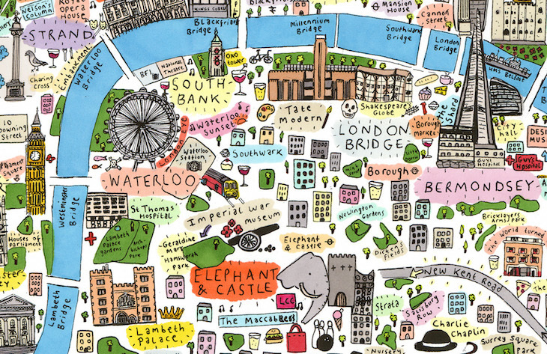

5/ Go to your superior and tell him about the situation in English !

