Coca-Cola Adopts One-Brand Strategy in Europe and the US to Clear Up Confusion
Posted March 5, 2015 by Mark J. Miller
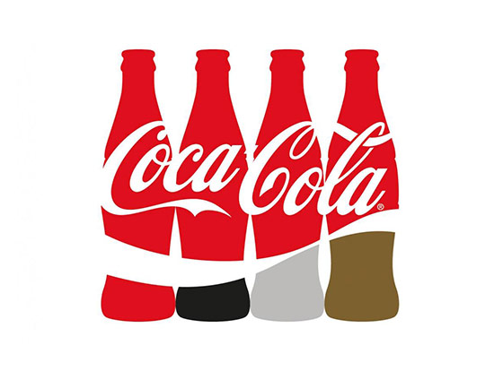
The Coca-Cola Company spends a lot of time, energy and money marketing its many different brands.
The company, however, is taking a different tack in the UK and put all of its Coca-Cola products—Coca-Cola, Diet Coke, Coke Zero and Coke Life—into a unified brand architecture to clean up any confusion in the marketplace—especially around its beverage brands with reduced sugar and calories.
Researches showed that UK consumers do not fully understand the difference between the four brands, with five percent having no idea that Coca-Cola has no sugar or calories, for example.
Now, by putting them all under the Coca-Cola name, the global beverage giant hopes to differentiate them on the actual packaging.
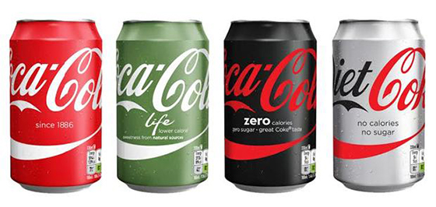
The branding on all cans will be the same, but distinct coloring will help distinguish the varieties as the old logos move from vertical to horizontal.
Starting in May, all Coca-Cola advertising and messaging in the UK will feature the four brands. The new campaign, which will shift the brand’s tagline from “Open happiness” to “Choose happiness,” will be showcased this fall at the Coke brand sponsored Rugby World Cup.
“By focusing on building one brand and extending the appeal of the original Coca-Cola across our lower- and no-sugar variants, we believe we can drive sustainable growth for our business in Great Britain in the years ahead,” stated Jon Woods, General Manager of Coca-Cola Great Britain & Ireland.
The UK brand refresh is stretching across Europe with the notable exception of Spain: “the new cans and bottles have started to hit store shelves now in 12 European countries, while two of the designs (for Coca-Cola and Coke Zero) are being distributed across the US.”
VOCABULARY:
To clear up: clarifier / dissiper
Tack: tactique
Questions:
1 – Present the organization in the document.
2 – Explain Coca Cola’s new strategy.
3 – What is the reason of this new strategy? As a consumer, do you think it’s a good strategy? Explain.

