Thursday
I’m having a seriously hard time getting used to the fact that summer is over and I have to get out of bed every morning to go to school.
My summer did not exactly get off a great start, thanks to my older brother Roderick. A couple of days into summer vacation, Roderick woke me up in the middle of the night. He told me I slept through the whole summer, but that luckily I woke up just in time for the first day of school.
You might think I was pretty dumb for falling for that one, but Roderick was dressed up in his school clothes and he’d set my alarm clock ahead to make it look like it was the morning. Plus, he closed my curtains so I couldn’t see that it was still dark out. // 1
After Roderick woke me up, I just got dressed and went downstairs to make myself some breakfast, like I do every morning on a school day.
But I guess I must have made a pretty big racket because the next thing I knew, Dad was downstairs, yelling at me for eating Cheerios at 3:00 in the morning. It took me a minute to figure out what the heck was going on.
After I did, I told Dad that Roderick had played a trick on me, and HE was the one that should be getting yelled at. // 2
Dad walked down to the basement to chew Roderick out, and I tagged along. I couldn’t wait to see Roderick get what was coming to him. But Roderick covered up his tracks pretty good. And to this day, I sure Dad thinks I’ve got a screw loose or something.// 3

From Diary of a Wimpy Kid by Jeff Kinney.

1) Read the text at least twice and tick the right box or answer the questions:

This document is
an extract from a history book a biography an extract from a diary.

Give some clues to justify your answer:
……………………………………………………………………………………………………………………………………………………………………………………………………………………………………………………………………………………………..

Match the following drawings with the right paragraph.
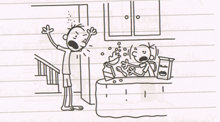
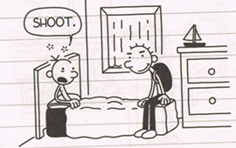
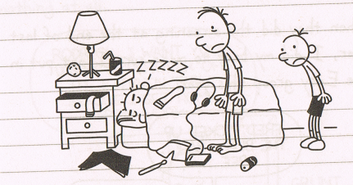

§ n°………………………… § n°…………………… § n°………………………

2) Read paragraph one.

a) Tick the right boxes

The action took place during summer time school time

Greg is an early riser true false

Rodrick is Greg’s little brother elder brother

b) All the following statements are wrong ! Correct them by quoting the text.

Rodrick let Greg sleep very late in the morning.
………………………………………………………………………………………………………………………………………………
Rodrick had his tracksuit on to go to his karate training lesson.
………………………………………………………………………………………………………………………………………………
Greg’s alarm clock was out of order.
………………………………………………………………………………………………………………………………………………
It was a sunny day.
………………………………………………………………………………………………………………………………………………

c) Choose a synonym of “dumb”
sleepy stupid

d) Roderick made fun of his brother Roderick had fun with his brother

3) Read paragraph two.

a) Tick the right boxes

Greg’s father went down to the kitchen because
Roderick told him Greg was having breakfast at 3: 00 in the morning
Greg made a lot of noise

Greg was surprised
Greg was afraid

Greg’s father only shouted at him
Greg’s father got angry with both his sons

Greg denounced his brother
Greg went back to bed

4) Read paragraph three.
Guess the meaning of these expressions thanks to the context
To chew out to blow your chewing gum away reprimand
To tag along to follow someone to draw on street walls
To cover one’s track to loose one’s way to destroy the clues
To have a screw loose to be mad to be cool

Why did Greg’s Dad go down to Roderick’s room?

……………………………………………………………………………………………………………………………………………..

What couldn’t Greg wait for?

……………………………………………………………………………………………………………………………………………….

What happened in the end?

………………………………………………………………………………………………………………………………………………

KEY

1) Read the text at least twice and tick the right box or answer the questions:

This document is
an extract from a history book a biography an extract from a diary.

Give some clues to justify your answer:
There’s a date (Thursday, the font (handwritten), the pronoun “I”).

Match the following drawings with the right paragraph.

§ n° 3 § n° 1 § n 2

2) Read paragraph one.

a) Tick the right boxes

The action took place during summer time school time

Greg is an early riser true false

Rodrick is Greg’s little brother elder brother

b) All the following statements are wrong ! Correct them by quoting the text.

Rodrick let Greg sleep very late in the morning.
“Roderick woke me up in the middle of the night.”

Rodrick had his tracksuit on to go to his karate training lesson.
“Roderick was dressed up in his school clothes.”

Greg’s alarm clock was out of order.
“He’d set my alarm-clock ahead.”

It was a sunny day.
“I couldn’t see that it was still dark out.”

c) Choose a synonym of “dumb”
sleepy stupid

d) Roderick made fun of his brother Roderick had fun with his brother

3) Read paragraph two.

a) Tick the right boxes

Greg’s father went down to the kitchen because
Roderick told him Greg was having breakfast at 3: 00 in the morning
Greg made a lot of noise

Greg was surprised
Greg was afraid

Greg’s father only shouted at him
Greg’s father got angry with both his sons

Greg denounced his brother
Greg went back to bed

4) Read paragraph three.
Guess the meaning of these expressions thanks to the context
To chew out to blow your chewing gum away reprimand
To tag along to follow someone to draw on street walls
To cover one’s track to loose one’s way to destroy the clues
To have a screw loose to be mad to be cool

Why did Greg’s Dad go down to Roderick’s room?

He wanted to punish him for having played a very bad trick on his little brother.

What couldn’t Greg wait for?

He was looking forward to see his father yell at Roderick. Tit for tat !!

What happened in the end?

Greg was disappointed because when they both came into his bedroom, Roderick pretented to be fast asleep, he hadn’t left any clues behind ! Now Greg is worried because his family might think he is crazy !

