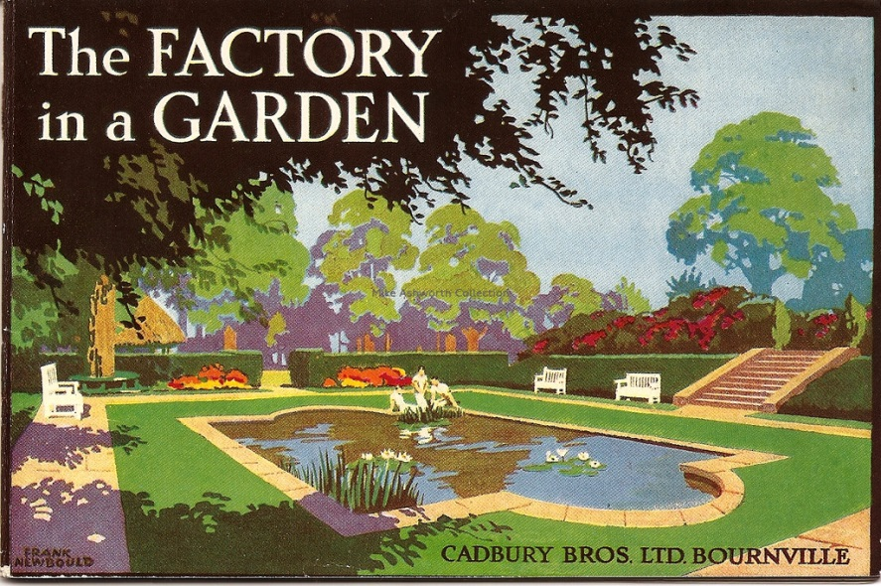
In 1847, the Cadbury brothers' booming business moved into a new, larger factory in Bridge Street in the centre of Birmingham. When the Bridge Street factory became too small, George Cadbury had a new vision of the future. 'Why should an industrial area be squalid and depressing?’ he asked. His vision was shared by his brother Richard, and they began searching for a very special site for their new factory.
In 1878 the brothers found their new home. They chose a 14½ acre greenfield site between the villages of Stirchley, King's Norton and Selly Oak, about four miles south of central Birmingham. The site comprised a meadow with a cottage and a trout stream - the Bourn. The cottage isn’t there any more, but the pear tree from its garden still stands outside the main Cadbury reception at the Bournville factory. The factory was initially going to be called, Bournbrook, after the cottage and Bournbrook Hall which stood nearby. But instead, 'Bournville' was chosen - combining the name of the stream with 'ville', the French word for town. At Bournville, workers lived in far better conditions than they'd experienced in the crowded slums of the city. The new site had canal, train and road links and a good water supply. There was lots of room to expand, which was lucky, because George’s plans for the future were ambitious. He wanted to build a place full of green spaces, where industrial workers could thrive away from city pollution. 'No man ought to be condemned to live in a place where a rose cannot grow.’ George Cadbury.
BOURNVILLE 'THE FACTORY IN A GARDEN' IS BORN
Birmingham architect, George H. Gadd worked closely with George Cadbury to draw up plans for the factory. The first bricks were laid in January 1879 and 16 houses for foremen and senior employees were built on the site.
These mostly semi-detached houses were well-built and spaced out with ample gardens. Production began at the Cadbury Brothers' 'Bournville factory in a garden' in September 1879. When the workers arrived they found facilities that were simply unknown in Victorian times. There was a field next to the factory where men were encouraged to play cricket and football; a garden and playground for the girls; a kitchen where workers could heat up their meals, and properly heated dressing rooms where they could get changed. As George said, 'If the country is a good place to live in, why not to work in?’ Keen sportsmen, Richard and George encouraged sports and recreations, often playing cricket themselves. Sports facilities grew to include football, hockey and cricket pitches, tennis and squash racquet courts and a bowling green. Gradually women's and men's swimming pools were built and every young boy and girl joining the company was encouraged to become a good swimmer. Work outings to the country were organised together with summer camps for the young boys. Morning prayers and daily bible readings, first started in 1866, helped preserve the family atmosphere and continued for another 50 years, until the workforce grew too large for such an assembly. For workers who still needed to travel to the new factory from their homes in Birmingham, the Cadbury brothers negotiated special workmen's train fares to Bournville’s Stirchley Station with the local railway company. Cadbury duly became famous not just for its prosperity, but also for the advances in conditions and social benefits for its workforce.

