DO FORMER TRANSPORT MINISTERS DREAM OF ELECTRIC BUSES?

Ex Lib Dem MP Norman Baker has swapped the ‘constant battle’ of working with Theresa May for running a Brighton eco-firm that’s launching a green bus route. Norman Baker is the new managing director of the Big Lemon bus company (…), a 10-year-old, eco-friendly bus operator in Brighton, where its single-deckers run on cooking oil – 112 tonnes of fat was used to fuel 16 buses and coaches for nearly 220,000 miles last year.

Partly through crowdfunding and two-year bonds of £100 each to the local community, the Big Lemon last year raised £250,000 to convert two 25-seater buses to run on electricity deriving from solar power. More than 120 panels have been installed on the depot in Brighton, where the buses will be charged at night.

In summer, excess electricity will be pumped into the grid. In winter, the buses will draw some electricity from the grid, but it is expected that through the year the solar panels will generate slightly more electricity than the buses need.

“We’re a very popular outfit in Brighton, we’re seen as environmentally friendly,” says Baker. (…)

The guardian. 24/04/2017

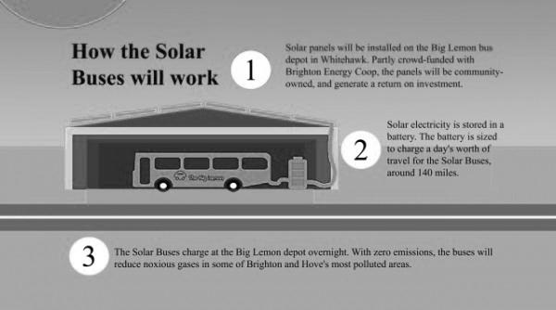

https://www.thenews.coop/108824/sector/energy/co-op-joins-bus-company-create-100-renewable-energy-transport/

Questions:

1. Who is Norman Backer? What does he want to do?
2. How financed the electric bus? Explain the principle of this sort of financement.
3. With what kind of energy were the buses powered until now?
4. In what ways does this company show corporate social responsibility?
5. How does the electric bus work?

Vocabulary:
To swap: échanger
Outfit: boîte (entreprise)
Grid: réseau (éléctrique)

